The Jain International School , Kanpur
Class – I
SUBJECT | SUMMER HOLIDAY HOMEWORK
English | Do the given worksheets.  Roll no. 1 to 4 – Make a chart on Article.  Roll no. 5 to 8 – Make a working model on Naming words.  Roll no. 9 to 12 – Make a chart on Opposites.  Roll no. 13 to 17 - Make a working model on Sentence formation.
Hindi | Do the given worksheets.  Roll No. 1 to 5 : Make a working model on - opu loZuke Loj A  Roll No. 6 to 10 : Make a chart on- Loj O;atu ek=k,W fyax A  Roll No. 11 to 16 : Make a working model on- Loj O;atu opu fyax A
Mathematics | Do the given worksheets. Make a chart on the given topic  Roll No -1 to 4 – Shapes and Patterns  Roll No- 5 to 8 – Time  Make a working model on the given topic  Roll No – 9 to 12 – Abacus  Roll No – 13 to 17 – Signs (<,>,=)
Social Studies | Do the given sheets.  Roll no. 1 to 5 – Make a chart on Helpers.  Roll no. 5 to 11– Make a working model on Different means of transport  Roll no. 12 to 17 – Make a chart on different types of food
Science | Do the given worksheets. Make a chart on any one of the following topics:  Roll no. 1 to 4 Uses of air  Roll no. 5 to 8 Sources of water  Roll no. 9 to 12 Sources of food  Roll no. 13 to 17 Healthy eating habits
Computer | Make a chart on Main Parts of a Computer.  Or  Make a chart on uses of computer in different area like school, shops, homes, hospitals, banks, railway station, airports and post offices.  Or  Make a chart on input devices and output devices.  Or  Make a chart on additional part of computers.
General Knowledge | Paste the pictures of Places of worship and Festivals of India in G.K notebook.  Make a chart on any one of the following topics:  - Means of Transport  - Our National Symbols  - Monuments  Write any 10 current affairs in your G.K. notebook.

The Jain International School , Kanpur
Holiday Homework Worksheets - 1
Subject: English
Class – I
Name:______________________ Date : _____________
_________________________________________________________________________
TOPIC : SENTENCE
Q. Put these words in the correct order to make sentences. Use Capital Letters and Full Stop:-
1)the sun moves behind the clouds
_______________________________________________________
2) it has brown spots on its body
_______________________________________________________
3. the peacocks dance
_______________________________________________________

4. the children play in the mud
_______________________________________________________
“I am” is the shortest sentence in EnglishLanguage.
5. the rainbow looks beautiful
_______________________________________________________
6. everything looks beautiful
_______________________________________________________
7. water is very important
_______________________________________________________
8. we use it to drink
_______________________________________________________

The Jain International School , Kanpur
Holiday Homework Worksheets - 2
Subject: English
Class – I
Name:______________________ Date : _____________
_________________________________________________________________________
TOPIC : ONE AND MANY
Q. Write the Plural of the following Nouns:-
1)candle ___________ 2)radish ___________
3) tiger ___________ 4)house ___________
5) bench ___________ 6)bunch ___________
7)hotel ___________ 8)beach __________
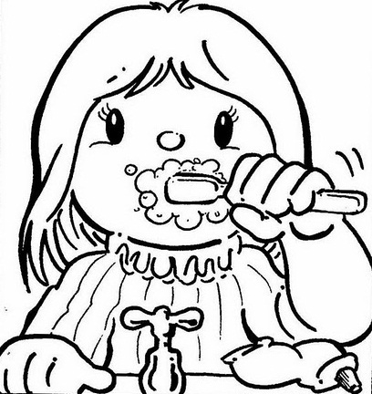
9)dog ___________ 10)ship __________
11) lunch __________ 12) duck __________
13) patch ___________ 14) toothbrush ___________
15) car __________ 16) torch ___________

- The most common letter in English is "e".
- The most common vowel in English is "e", followed by "a".
- The most common consonant in English is "r", followed by "t".

THE JAIN INTERNATIONAL SCHOOL
HOLIDAY HOME WORK
CLASS-1
Sheet No.1

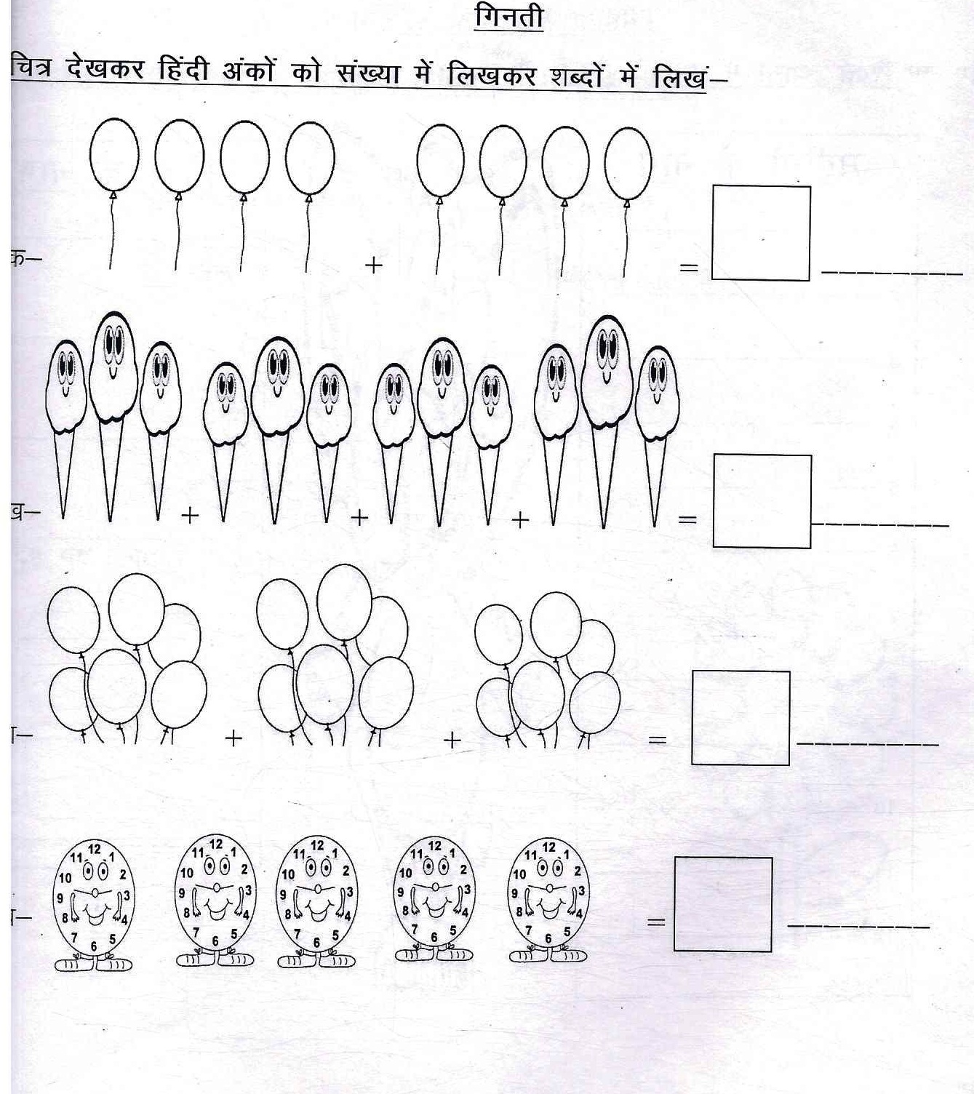

THE JAIN INTERNATIONAL SCHOOL
HOLIDAY HOME WORK
CLASS-1
Sheet No.2

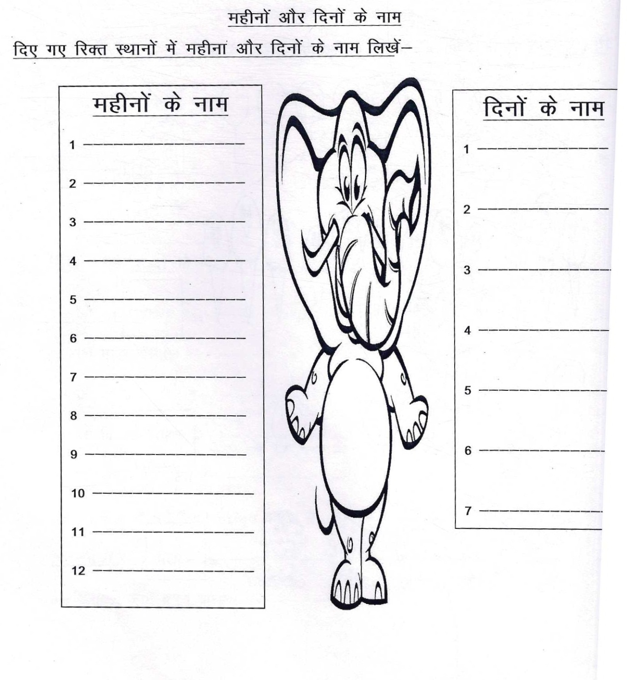

The Jain International School, Kanpur
Subject: Mathematics
Holiday Homework Worksheet 1
Class – I
Name:- ___________________ Date: _______________
TOPIC :SHAPES
Q. Guess and match with correct shape:-
I am round. I have no sides.

I have four equal sides and four corners.

I have three sides and three corners.

I have two opposite sides equal in length.

I have five sides and five corners

I have six sides and six corners
An icosagon is a shape with 20 sides. A nonagon has 9 sides.An octagon has 8 sides. A heptagon has 7 sides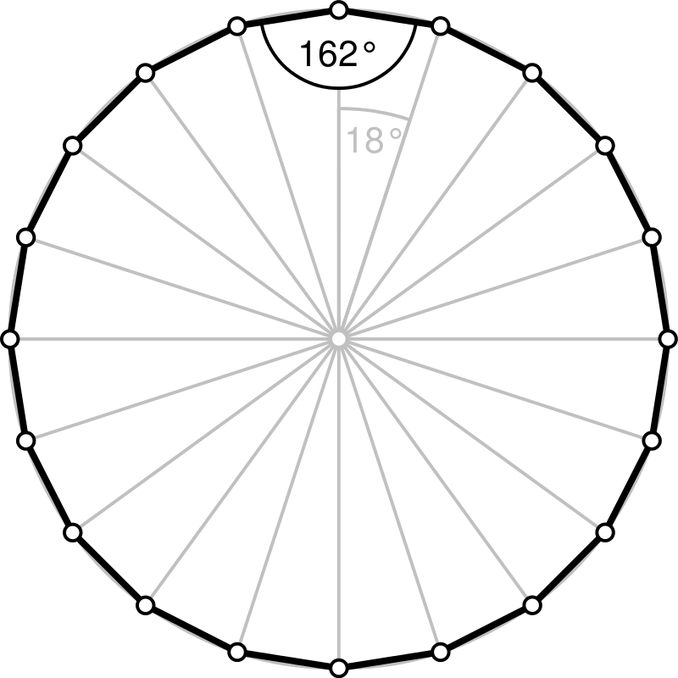

The Jain International School , Kanpur
Subject: Mathematics
Holiday Homework Worksheet 2
Class – I
Name:- ___________________ Date: _______________
TOPIC :PATTERNS
Q.Complete the given pattern:-
a) | 1 | 3 | 5 | ____ | ____ | ____ | ____
b) | 4 | 8 | 12 | ____ | ____ | ____ | ____
c) | 5 | 10 | 15 | ____ | ____ | ____ | ____
d) | 10 | 20 | 30 | ____ | ____ | ____ | ____
e) | 20 | 23 | 26 | ____ | ____ | ____ | ____
f) | 51 | 55 | 59 | ____ | ____ | ____ | ____
g) | 3 | 6 | 9 | ____ | ____ | ____ | ____
h) | 55 | 45 | 35 | ____ | ____ | ____ | ____
i) | 15 | 11 | 9 | ____ | ____ | ____ | ____
Palindrome is a number that reads the same backward and forward, e.g. 12421

The Jain International School, Kanpur
Subject: Science
Holiday Homework Worksheet 1
Class – I
Name:- ___________________ Date: _______________
FAMILY
QA-Tick the correct statement and cross the wrong ones:-
1. | My mother and father love me. | [ | ]
2. | There are many members in a small family. | [ | ]
3. | Parents earn money for their family. | [ | ]
4. | My mother and father are my parents. | [ | ]
5. | My parent’s son is my daughter. | [ | ]
6. | All the members of a family have different surnames. | [ | ]
7. | People who come to your house are called guests. | [ | ]
8. | We should not keep our books and toys in its place. | [ | ]
QB-Paste the pictures of your ‘family members’ below:-

The Jain International School , Kanpur
Subject: Science
Holiday Homework Worksheet 2
Class – I
Name:- ___________________ Date: _______________
HELPING HANDS
Identify the pictures and write the names:-

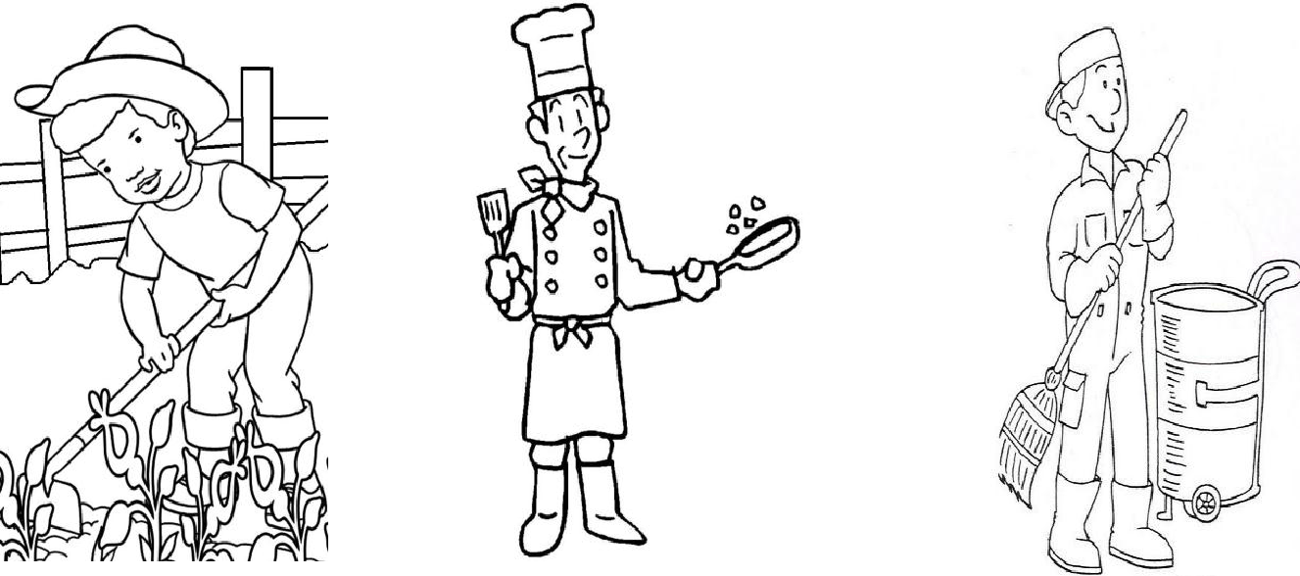
1. 2. 3.

___________________

__________________

________________
4

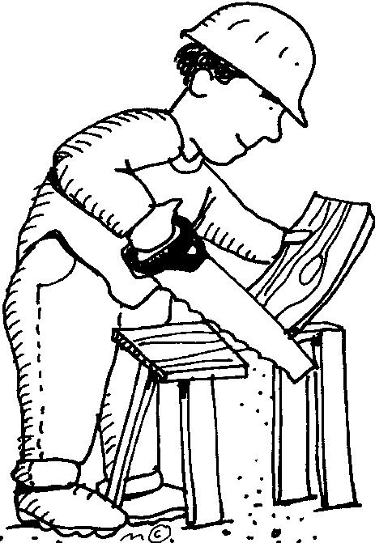
5 6.

The Jain International School , Kanpur
Subject: Social Studies
Holiday Homework Worksheet 1
Class – I
Name:- ___________________ Date: _______________
___________________________________________________________________________________
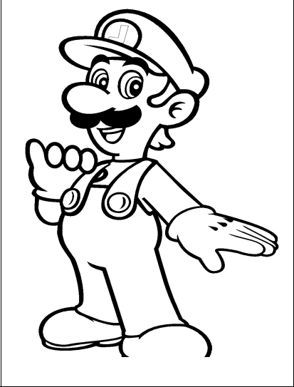
MEET ME
- My name is __________________________________.

- I am a __________. (boy / girl)

- I am ___________ years old.

4.I am in class ____________.
- The name of my school is _____________________________________________.

- My mother’s name is ___________________________________.

- My father’s name is ____________________________________.

- My teacher’s name is ___________________________________.

Paste your photo below of the best memory of your ‘infant’:-

The Jain International School , Kanpur
Subject: Social Studies
Holiday Homework Worksheet 2
Class – I
Name:- ___________________ Date: _______________
___________________________________________________________________________________
HEALTHY AND CLEAN
Name the four things we use to take care of our body:-

1.
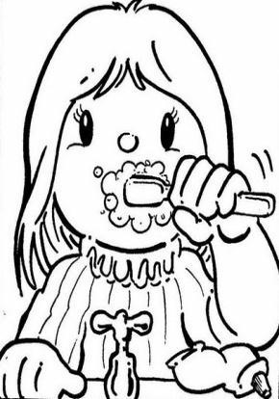

________________________________

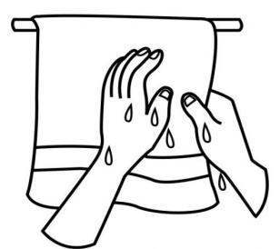
2.

________________________________

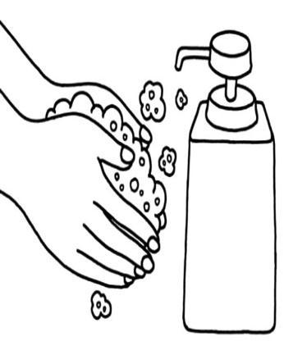
3.

________________________________

4.

